

# 

### Semester One Examination, 2017

### Question/Answer booklet

# MATHEMATICS

**SOLUTIONS**

**METHODS**

**UNIT 1**

## Section Two:

## Calculator-assumed

|  |  |  |  |  |  |  |  |  |  |  |
| --- | --- | --- | --- | --- | --- | --- | --- | --- | --- | --- |
| Student Number: In figures |  |  |  |  |  |  |  |  |  |  |

In words

Your name

## Time allowed for this section

Reading time before commencing work: ten minutes

Working time: one hundred minutes

## Materials required/recommended for this section

***To be provided by the supervisor***

This Question/Answer booklet

Formula sheet (retained from Section One)

***To be provided by the candidate***

Standard items: pens (blue/black preferred), pencils (including coloured), sharpener, correction fluid/tape, eraser, ruler, highlighters

Special items: drawing instruments, templates, notes on two unfolded sheets of A4 paper, and up to three calculators approved for use in this examination

## Important note to candidates

No other items may be taken into the examination room. It is **your** responsibility to ensure that you do not have any unauthorised material. If you have any unauthorised material with you, hand it to the supervisor **before** reading any further.

## Structure of this paper

|  |  |  |  |  |  |
| --- | --- | --- | --- | --- | --- |
| Section | Number of questions available | Number of questions to be answered | Working  time (minutes) | Marks available | Percentage of examination |
| Section One:  Calculator-free | 7 | 7 | 50 | 52 | 35 |
| Section Two:  Calculator-assumed | 13 | 13 | 100 | 98 | 65 |
|  | | |  | **Total** | 100 |

## Instructions to candidates

1. The rules for the conduct of examinations are detailed in the school handbook. Sitting this examination implies that you agree to abide by these rules.

2. Write your answers in this Question/Answer booklet.

3. You must be careful to confine your response to the specific question asked and to follow any instructions that are specified to a particular question.

4. Additional working space pages at the end of this Question/Answer booklet are for planning or continuing an answer. If you use these pages, indicate at the original answer, the page number it is planned/continued on and write the question number being planned/continued on the additional working space page.

5. Show all your working clearly. Your working should be in sufficient detail to allow your answers to be checked readily and for marks to be awarded for reasoning. Incorrect answers given without supporting reasoning cannot be allocated any marks. For any question or part question worth more than two marks, valid working or justification is required to receive full marks. If you repeat any question, ensure that you cancel the answer you do not wish to have marked.

6. It is recommended that you do not use pencil, except in diagrams.

7. The Formula sheet is not to be handed in with your Question/Answer booklet.

Section Two: Calculator-assumed 65% (98 Marks)

This section has**thirteen (****13)** questions. Answer **all** questions. Write your answers in the spaces provided.

Working time: 100 minutes.

Question 8 (6 marks)

(a) The variables and are directly proportional to each other, so that when , it is known that . Sketch a graph of the relationship between and on the axes below. (3 marks)

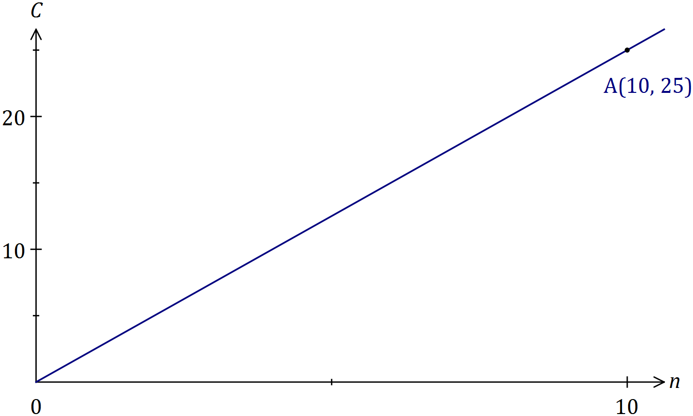

|  |
| --- |
| **Solution** |
| See graph |
| **Specific behaviours** |
| ✓ scales added to both axes  ✓ straight line through origin using ruler  ✓ indicates passes through (10, 25) |

(b) The variables and are inversely proportional to each other, so that when , it is known that .

(i) Write an equation that relates and . (2 marks)

|  |
| --- |
| **Solution** |
|  |
| **Specific behaviours** |
| ✓ correct form of equation  ✓ determines constant |

(ii) Determine the value of when . (1 mark)

|  |
| --- |
| **Solution** |
|  |
| **Specific behaviours** |
| ✓ states value |

Question 9 (9 marks)

(a) Determine the size, to the nearest degree, of the largest angle in a triangle with sides of lengths 23 cm, 28 cm and 31 cm. (3 marks)

|  |
| --- |
| **Solution** |
|  |
| **Specific behaviours** |
| ✓ shows use of cosine rule  ✓ substitutes correctly  ✓ determines angle |

(b) Determine the value of in the diagram below. (3 marks)

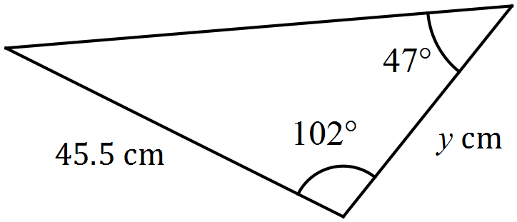

|  |
| --- |
| **Solution** |
|  |
| **Specific behaviours** |
| ✓ determines angle  ✓ shows use of sin rule  ✓ determines value |

(c) The area of the triangle shown below is 280 cm2. Determine the value of . (3 marks)

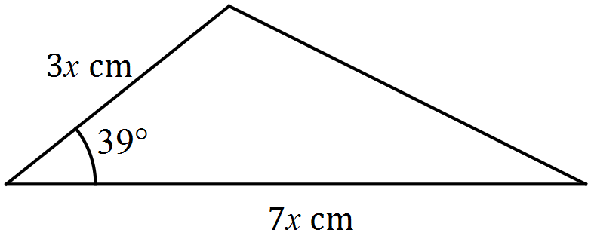

|  |
| --- |
| **Solution** |
|  |
| **Specific behaviours** |
| ✓ uses area formula  ✓ substitutes correctly  ✓ solves for value |

Question 10 (6 marks)

(a) State, with reasoning, which of the graphs shown below are **not** those of a function.

(3 marks)

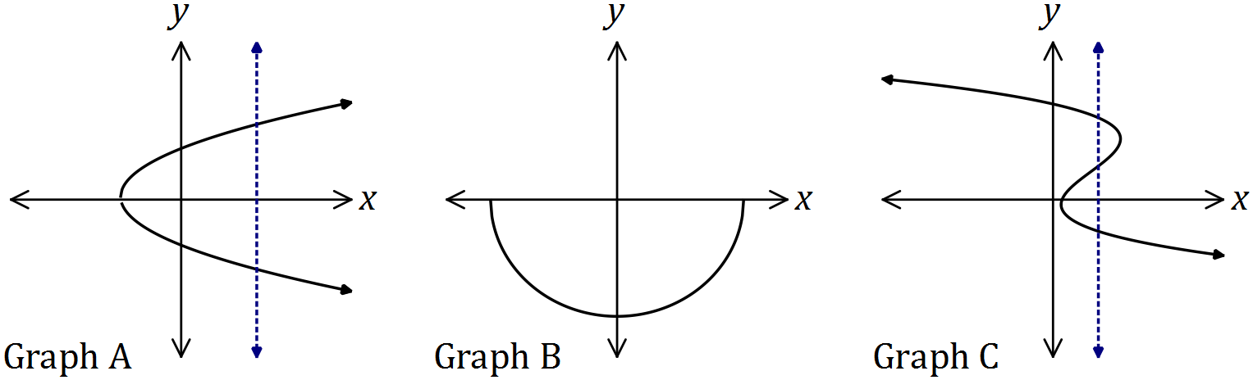

|  |
| --- |
| **Solution** |
| and are not graphs of functions, as a vertical line can be drawn to cut both in more than one place. |
| **Specific behaviours** |
| ✓ A  ✓ C  ✓ reasoning |

(b) Draw the graph of the relation . (3 marks)

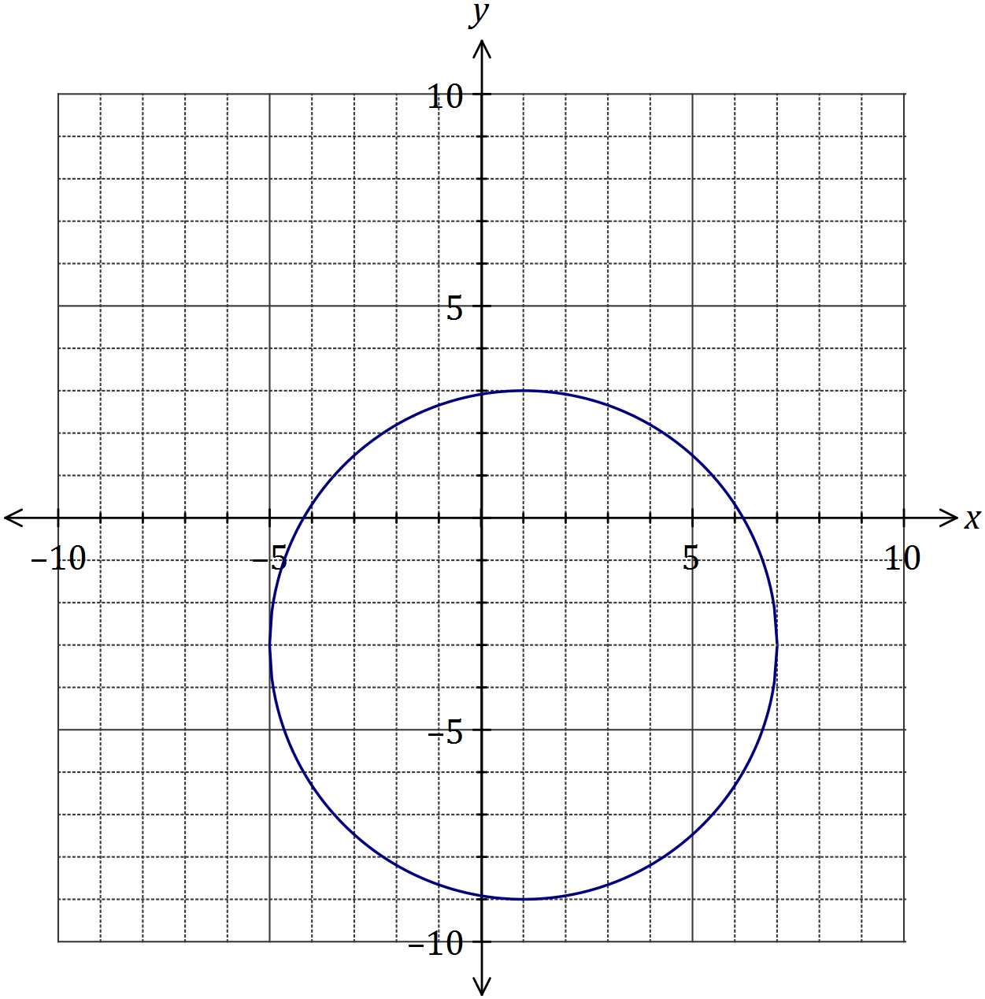

|  |
| --- |
| **Solution** |
| See graph |
| **Specific behaviours** |
| ✓ centred at (1, -3) and radius of 6  ✓ at least three axes-intercepts within  ✓ smooth circle |

Question 11 (6 marks)

(a) The graphs of and are shown below.

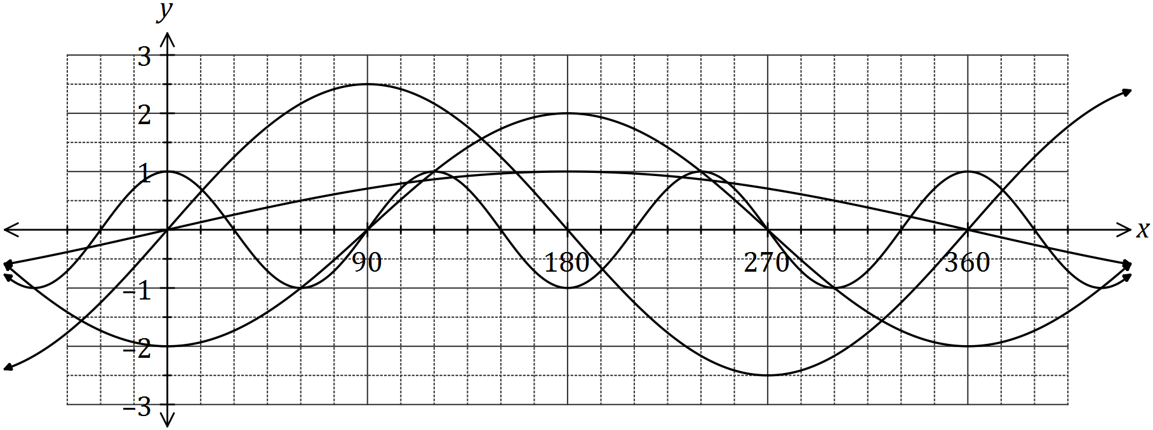

Determine the values of the constants and . (4 marks)

|  |
| --- |
| **Solution** |
|  |
| **Specific behaviours** |
| ✓✓✓✓ one mark per correct value |

(b) The graph of is drawn below.

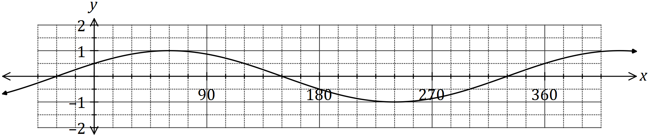

(i) State the value of the constant , where . (1 mark)

|  |
| --- |
| **Solution** |
|  |
| **Specific behaviours** |
| ✓ states value |

(ii) The graph is also that of . State the value of the constant , where . (1 mark)

|  |
| --- |
| **Solution** |
|  |
| **Specific behaviours** |
| ✓ states value |

Question 12 (8 marks)

(a) At 3 pm, the length of the shadow of a thin vertical pole standing on level ground is the same as the height of the pole. A while later, the angle of elevation of the sun has decreased by 12° and the length of the shadow has increased by 95 cm. Determine the height of the pole. (4 marks)

|  |
| --- |
| **Solution** |
|  |
| **Specific behaviours** |
| ✓ initial info sketch  ✓ extra info added to sketch  ✓ writes equation  ✓ solves equation with CAS |

(b) A windscreen wiper on a car is 43 cm long and rotates through one-third of a circle, as shown below. The inner and outer radii of the arcs are 20 cm and 63 cm. Determine the shaded area, rounding your answer to a reasonable degree of accuracy. (4 marks)

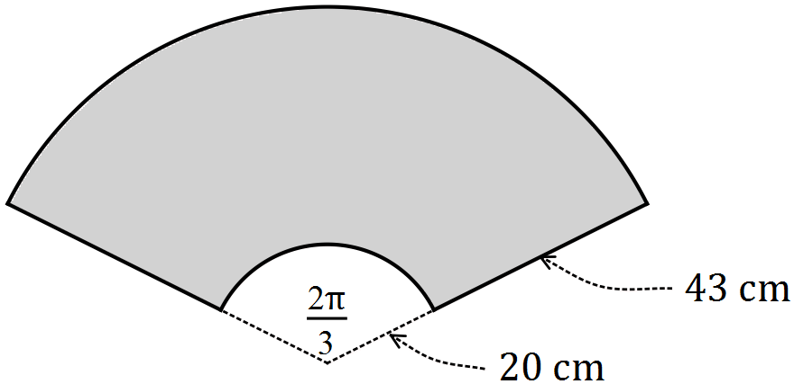

|  |
| --- |
| **Solution** |
|  |
| **Specific behaviours** |
| ✓ inner sector  ✓ outer sector  ✓ works throughout to at least 4 sf  ✓ rounds answer to 2 or 3 sf |

Question 13 (5 marks)

(a) Using the unit circle shown, determine the following in terms of and/or , given that is an acute angle measured in degrees.

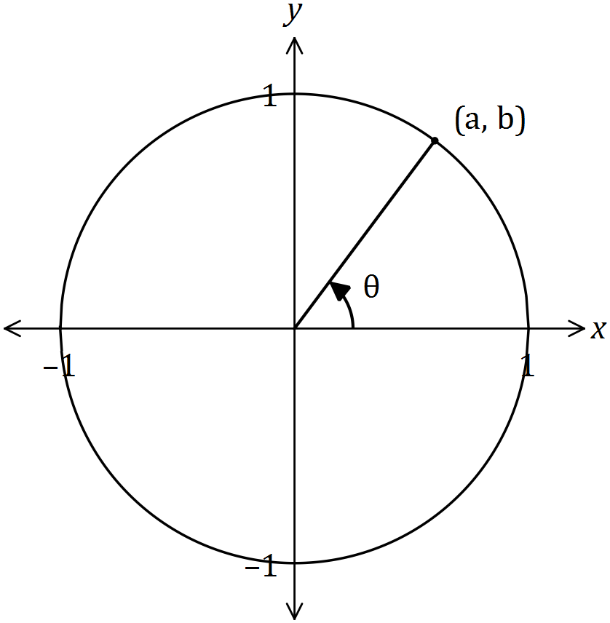

(i) (1 mark)

|  |
| --- |
| **Solution** |
| (i)  (ii)  (iii) |
| **Specific behaviours** |
| ✓ (i)  ✓ (ii)  ✓ (iii) |

(ii) . (1 mark)

(iii) . (1 mark)

(b) Determine in each of the following cases, where .

(i) . (1 mark)

|  |
| --- |
| **Solution** |
| (i)  (ii) |
| **Specific behaviours** |
| ✓ (i)  ✓ (ii) |

(ii) . (1 mark)

Question 14 (8 marks)

(a) The graph of has a line of symmetry with equation .

(i) Determine the value of . (2 marks)

|  |
| --- |
| **Solution** |
|  |
| **Specific behaviours** |
| ✓ uses line of symmetry  ✓ value of |

(ii) Draw the graph of the parabola on the axes below. (3 marks)

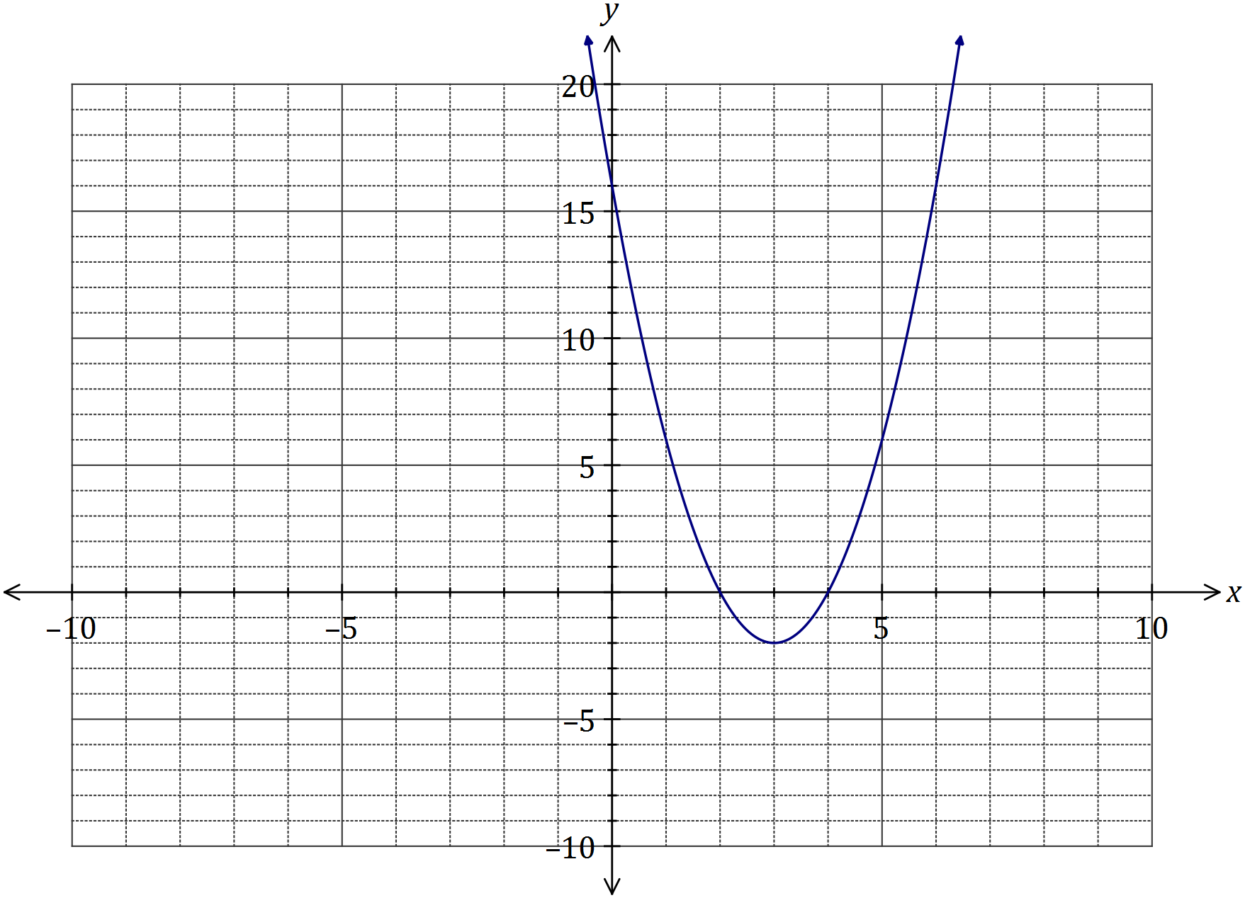

|  |
| --- |
| **Solution** |
| See graph |
| **Specific behaviours** |
| ✓ turning point  ✓ three axes intercepts  ✓ smooth curve |

(b) One of the solutions to the equation is . Determine the value of and all other solutions. (3 marks)

|  |
| --- |
| **Solution** |
| Using CAS, when  Use CAS to solve |
| **Specific behaviours** |
| ✓ substitutes  ✓ determines  ✓ states other two solutions |

Question 15 (8 marks)

(a) On the axes below, draw the graph of over the interval , clearly indicating the equations of any asymptotes. (3 marks)

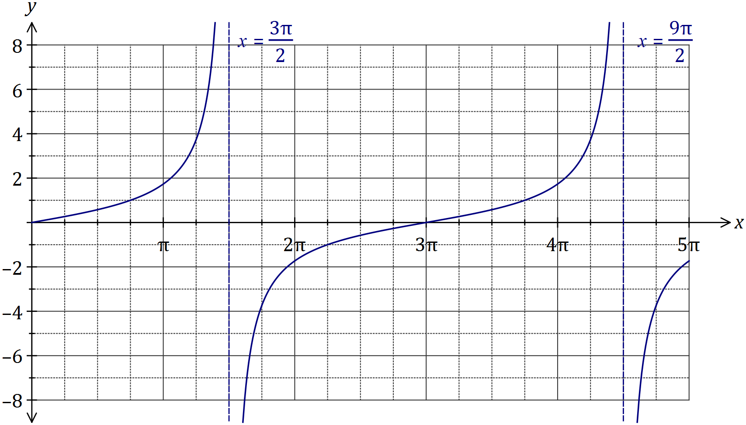

|  |
| --- |
| **Solution** |
| See graph |
| **Specific behaviours** |
| ✓ roots  ✓ general shape  ✓ equations of asymptotes |

(b) Solve the following equations over the interval .

(i) . (1 mark)

|  |
| --- |
| **Solution** |
|  |
| **Specific behaviours** |
| ✓ one solution |

(ii) . (2 marks)

|  |
| --- |
| **Solution** |
|  |
| **Specific behaviours** |
| ✓ first solution  ✓ second solution |

(c) Determine the smallest positive value of so that . (2 marks)

|  |
| --- |
| **Solution** |
| Function has period of and so |
| **Specific behaviours** |
| ✓ uses period  ✓ determines |

Question 16 (8 marks)

The graph of the function is defined by is shown below.

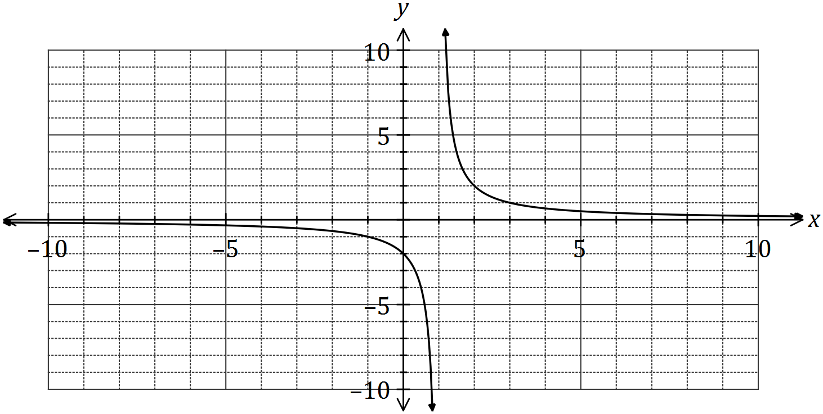

(a) Determine the values of and . (2 marks)

|  |
| --- |
| **Solution** |
| Using vertical asymptote,  Using -intercept, |
| **Specific behaviours** |
| ✓ value of , ✓ value of |

(b) State the domain and range of . (2 marks)

|  |
| --- |
| **Solution** |
|  |
| **Specific behaviours** |
| ✓ indicates , ✓ indicates |

(c) Determine the equations of the asymptotes of the graph of . (2 marks)

|  |
| --- |
| **Solution** |
| Vertical asymptote: , horizontal asymptote: |
| **Specific behaviours** |
| ✓ vertical asymptote, ✓ horizontal asymptote. |

(d) Describe the transformation required on the graph of to obtain the graph of

(i) . (1 mark)

|  |
| --- |
| **Solution** |
| Translate 8 units to the left. |
| **Specific behaviours** |
| ✓ description |

(ii) . (1 mark)

|  |
| --- |
| **Solution** |
| Dilate vertically by scale factor |
| **Specific behaviours** |
| ✓ description |

Question 17 (9 marks)

A straight line with equation , a parabola with equation and a cubic with equation all pass through the points and .

(a) Determine the values of the constants and in the equation of the straight line.

(2 marks)

|  |
| --- |
| **Solution** |
|  |
| **Specific behaviours** |
| ✓ determines gradient  ✓ determines -intercept |

(b) Determine the values of the constants , and in the equation of the parabola, given that is a minimum turning point of the parabola. (3 marks)

|  |
| --- |
| **Solution** |
|  |
| **Specific behaviours** |
| ✓ uses , turning point form and point  ✓ determines  ✓ expands and states other values |

(c) Draw the graph of the cubic on the axes below, given that is a point of inflection and is a maximum turning point of the cubic. (4 marks)

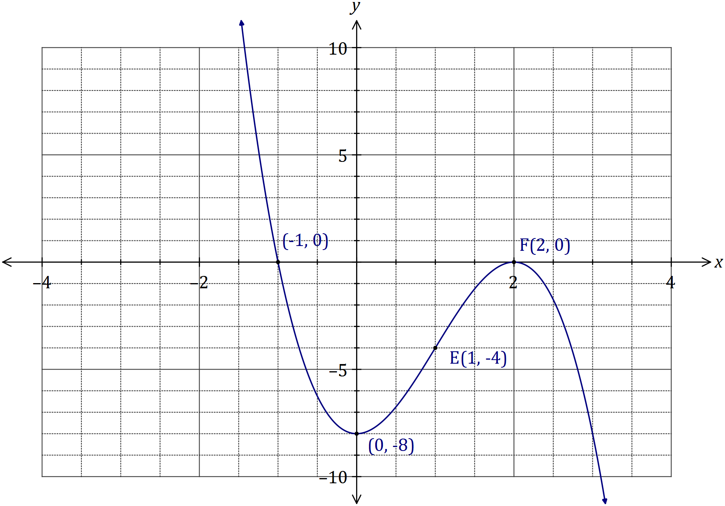

|  |
| --- |
| **Solution** |
| See graph |
| **Specific behaviours** |
| ✓ point of inflection at  ✓ maximum at  Uses rotational symmetry about point of inflection to obtain  ✓ minimum close to  ✓ root close to |

Question 18 (8 marks)

Over a 24-hour period, the depth of water, metres, in a harbour at time hours after midnight was given by

(a) Determine the depth of water at 11 pm. (1 mark)

|  |
| --- |
| **Solution** |
|  |
| **Specific behaviours** |
| ✓ states depth |

(b) Draw the graph of the water depth on the axes below. (3 marks)

|  |
| --- |
| **Solution** |
| See graph |
| **Specific behaviours** |
| ✓ location of start and maximums  ✓ location of end and minimums  ✓ smooth connecting curve |

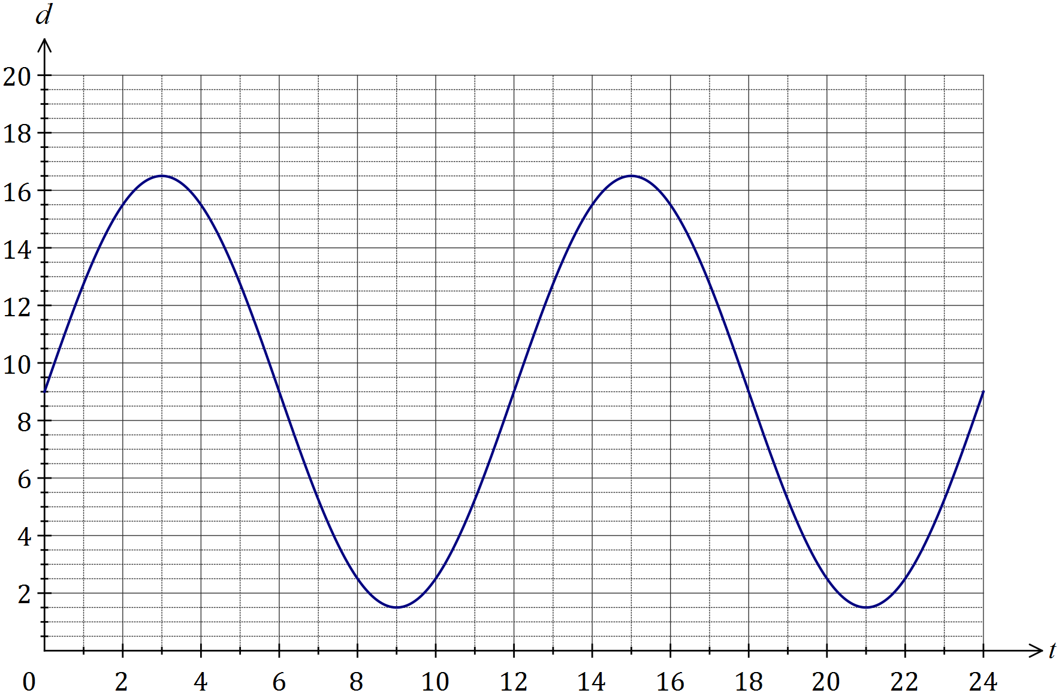

(c) At what time, in hours and minutes, did the depth of water first exceed 15 metres?

(2 marks)

|  |
| --- |
| **Solution** |
| - at 1:46 am |
| **Specific behaviours** |
| ✓ time as decimal  ✓ time in h and m |

(d) Determine the fraction of the 24-hour period during which the depth of water exceeded 12.75 m. (2 marks)

|  |
| --- |
| **Solution** |
| Between 1 am and 5 am in first 12 h. |
| **Specific behaviours** |
| ✓ determines time interval  ✓ states fraction |

Question 19 (8 marks)

The graph of is drawn below over its natural domain, where .

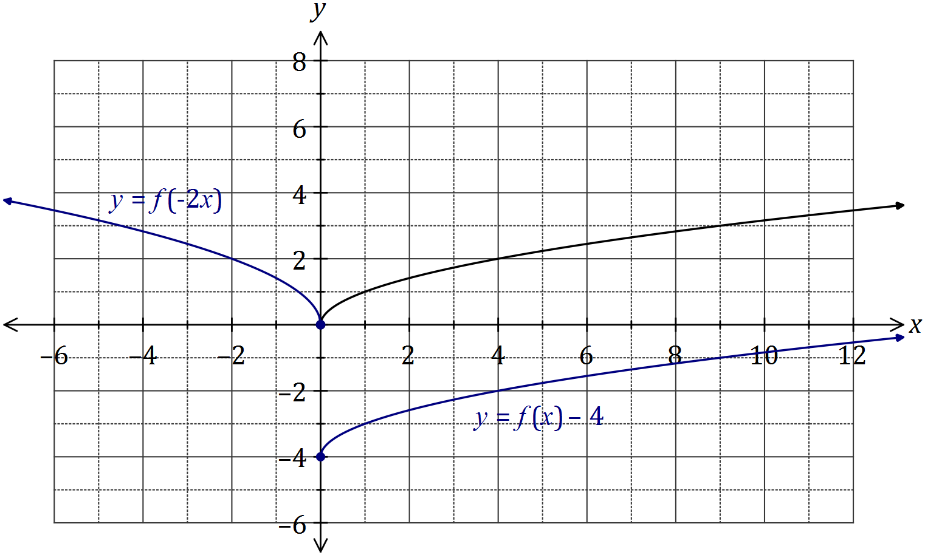

(a) The value of is either or . State the correct value of and justify your choice. (2 marks)

|  |
| --- |
| **Solution** |
| .  By substitution of , only gives a -coordinate of . |
| **Specific behaviours** |
| ✓ value  ✓ suitable justification |

(b) Explain why the domain of the function is . (2 marks)

|  |
| --- |
| **Solution** |
| . Hence the domain of is the set of non-negative real number, as it is not possible to determine the square root of negative real numbers. |
| **Specific behaviours** |
| ✓ all non-negative real numbers  ✓ explains square root issue |

(c) On the axes above, sketch and label the graphs of

|  |
| --- |
| **Solution** |
| See graph |
| **Specific behaviours** |
| ✓ starts at  ✓ smooth curve only in 4th quadrant |

(i) . (2 marks)

(ii) . (2 marks)

|  |
| --- |
| **Solution** |
| See graph |
| **Specific behaviours** |
| ✓ reflected in y-axis  ✓ dilated, passes close to |

Question 20 (9 marks)

(a) A running track has circular ends of radius 100 m and two straight, parallel sides and that are both 120 m long, as shown below. Determine, to the nearest metre, the total length of the track. (4 marks)

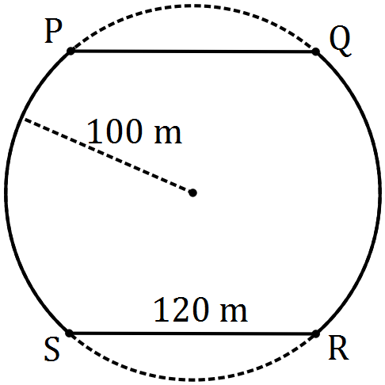

|  |
| --- |
| **Solution** |
|  |
| **Specific behaviours** |
| ✓ method to find arc angle  ✓ determines arc angle  ✓ arc length  ✓ total length |

(b) The diagram shows a circle with centre and diameter , and an equilateral triangle . Determine the exact fraction of the area of the circle that lies outside the triangle.

(5 marks)

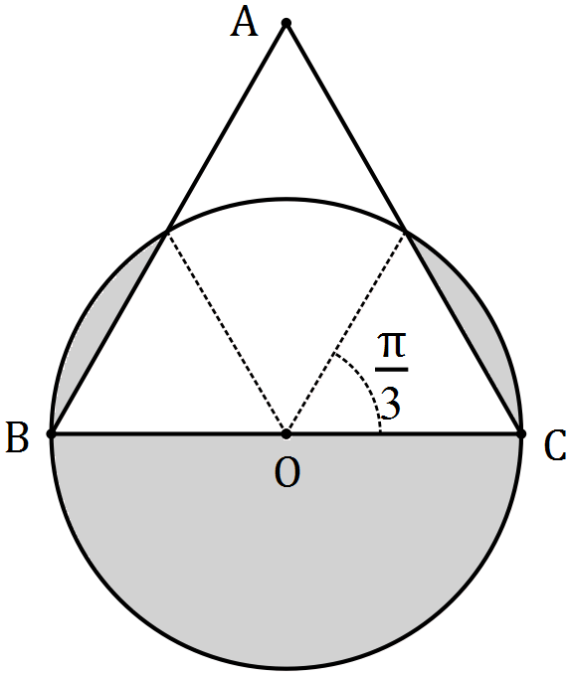

|  |
| --- |
| **Solution** |
|  |
| **Specific behaviours** |
| ✓ determines segment angle  ✓ determines segment area  ✓ determines total outside area  ✓ expresses outside as fraction of whole  ✓ simplifies (CAS) as exact value |

Additional working space

Question number: _________

© 2016 WA Exam Papers. Kennedy Baptist College has a non-exclusive licence to copy and communicate this paper for non-commercial, educational use within the school. No other copying, communication or use is permitted without the express written permission of WA Exam Papers. SN245-092-8.